 | KINGSTON UNIVERSITY LONDON

COURSEWORK ASSIGNMENT 2

Under the module
Data Analysis and Visualisation (CI7330)
M.Sc. Data Science

Submitted By
Akshay Margaj
(K2503574)

Question 1: Red Wine Quality Analysis

Introduction
The increasing sales of red wine sales has led both producers and authorities to consider automated methods for quality assessment that can consistently produce expert human ratings. The present study scrutinizes the extent to which 11 physicochemical lab measurements can predict the wine quality scores given by the experts in the wine industry. It takes the dataset of 1599 red wine samples and starts with an exploration of the data features and variable relationships. It then employs multiple linear regression and subsequently performs manual backward elimination to find the simplest model that can be relied upon for making predictions. In the end, the model's validity and prediction power are assessed.

Initial Data Exploration
The dataset has 1599 complete cases (i.e., no missing values). Basic statistics indicate that the quality variable is normally distributed (mean 6.13, SD 0.86), with the majority of the values falling within the range of 5 to 7. Alcohol, sulphates, and citric acid concentrations are the highest in wines of good quality, whereas those of volatile acidity, chlorides, and total SO₂ are the lowest.

Key variables used:
- fixacid: Fixed acidity score
- volacid: Volatile acidity score
- citric: Citric acid content
- residsugar: Residual sugar content
- chlorides: Chlorides by volume
- freeSO2: Free sulphur dioxide content
- totalSO2: Total sulphur dioxide content
- density: Density score
- pH: pH level
- sulphates: Sulphates level
- alcohol: Alcohol content (vol)
- Quality: Wine quality based on human expert ratings(y=Outcome)

Exploratory Data Analysis
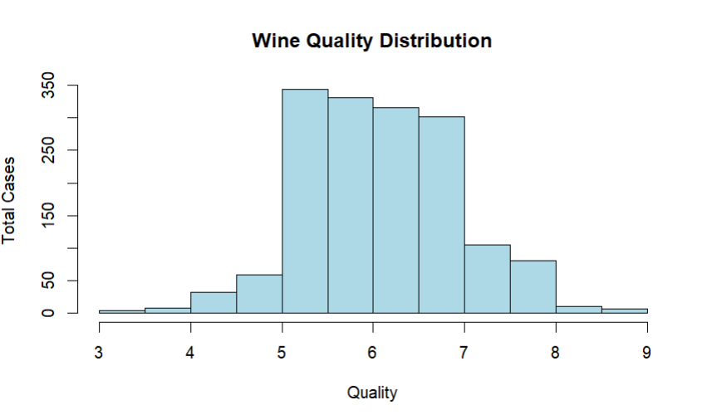
Figure 3.1: Wine Quality histogram
It can be seen from the histogram that the distribution of wine quality ratings is approximately normal, with the mean at 6 and the majority of the ratings between 5 and 7. Scoring below 4 or above 8 is very rare for wines.
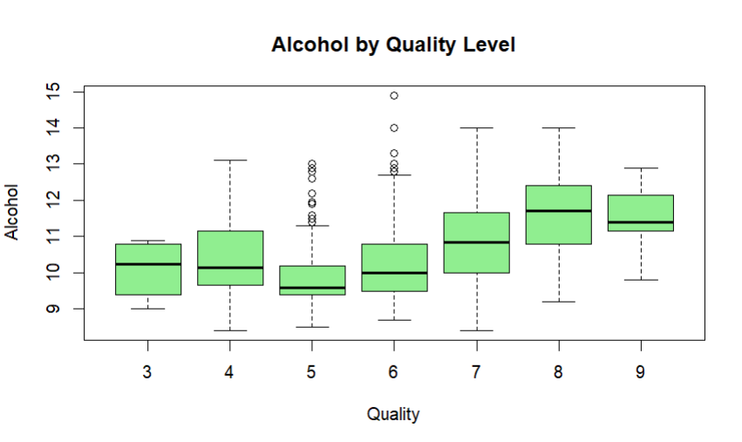
Figure 3.2: Alcohol boxplot at different quality levels

The boxplot depicts a strong positive correlation between quality and alcohol content quite clearly; the increase in median alcohol from about 9.5% in the case of lower-quality wines to over 11% in that of the higher-quality wines is quite noticeable.
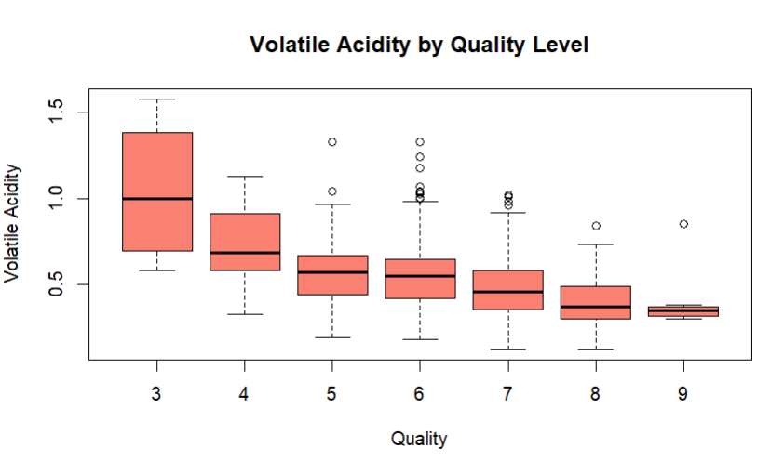
Figure 3.3: Volatile Acidity by Quality Level
The boxplot indicates a strong negative correlation: the lower the quality of the wine, the higher its volatile acidity, with the average values coming down gradually from about 0.7 in low-quality wines to around 0.4 in high-quality ones.
Correlation analysis shows:
- Strongest positive correlation: alcohol (r ≈ 0.45)
- Strongest negative correlation: volatile acidity (r ≈ –0.36)
- Moderate positive: sulphates (r ≈ 0.24), citric (r ≈ 0.20)
- Moderate negative: chlorides, total SO₂, density
Slight multicollinearity is present (fixed acidity ↔ citric acid ≈ 0.67; freeSO2 ↔ totalSO2 ≈ 0.66), which is usual and will be dealt with during model selection.
The data is proper and appropriate for regression. Alcohol and volatile acidity seem to be the most critical quality predictors, thus validating the adoption of multiple linear regression with variable selection.

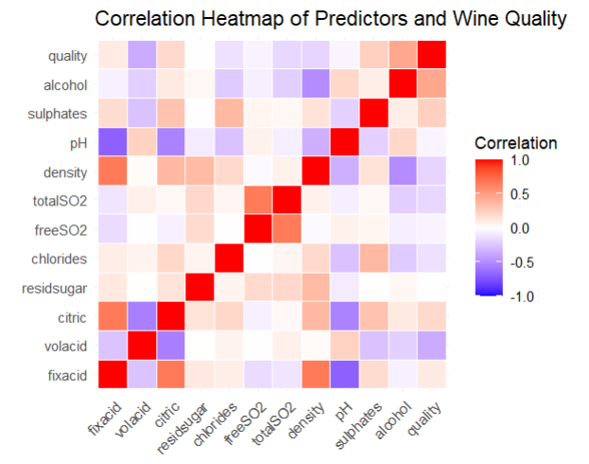
Figure 3.3: Correlation Heatmap of Predictors and Wine Quality
The correlation heatmap indicates the degree of correlation for each pair of predictors with wine quality (darker red = stronger positive correlation, darker blue = stronger negative correlation, white = almost no correlation).
Quality has the strongest positive correlations with:
- alcohol (~0.45), higher alcohol content is definitely a quality factor.
- sulphates (~0.24), the presence of sulphates in moderate amounts is a quality contributor.
The strongest negative correlation is:
- volatile acidity (~0.36) more volatile acidity equates to lower quality.
In addition to the above-mentioned variables, there are also moderate negative correlations with chlorides, total SO₂, and density. Separation among acidity-related variables (such as fixed acidity and citric acid ~0.67; free SO₂ and total SO₂~0.66) is moderate and thus supports the application of variable selection (backward elimination) in the regression modelling to prevent unstable estimates.
This heatmap supports the conclusion that alcohol, sulphates, and volatile acidity are the key determinants of wine quality while the influence of the other variables is either less significant or non-direct.

Linear Regression Analysis
The backward elimination technique was used to refine the model by removing insignificant predictors. The analysis starts with a full model and iteratively removes variables with highest p-values.
The full model (adjusted R² = 0.317) contained several insignificant predictors (p > 0.05).
Key steps of backward elimination (removing highest p-value each time):
- Removed freeSO₂ (p ≈ 0.118) → adjusted R² remained 0.317
- Removed residual sugar (p ≈ 0.629) → adjusted R² still 0.317
- Removed citric acid (p ≈ 0.080)
- Removed fixed acidity (p ≈ 0.945)
- Removed density (p ≈ 0.527)

Model 1: Full Model with All Predictors
model1 <- lm(quality ~ fixacid + volacid + citric + residsugar + chlorides + freeSO2 + totalSO2 + density + pH + sulphates + alcohol, data = wine)
Coefficients | Estimate | Std. Error | t value | p-value | Significance
Intercept | 18.640 | 23.190 | 0.804 | 0.421
Fixacid | 0.017 | 0.028 | 0.609 | 0.542
volacid | -1.065 | 0.133 | -8.036 | < 0.001 | ***
citric | -0.237 | 0.161 | -1.474 | 0.141
residsugar | 0.005 | 0.016 | 0.281 | 0.779
chlorides | -2.090 | 0.459 | -4.556 | < 0.001 | ***
freeSO2 | 0.004 | 0.002 | 1.563 | 0.118
totalSO2 | -0.003 | 0.001 | -3.697 | < 0.001 | ***
density | -13.850 | 23.670 | -0.585 | 0.559
pH | -0.479 | 0.210 | -2.287 | 0.022 | *
sulphates | 0.994 | 0.125 | 7.947 | < 0.001 | ***
alcohol | 0.284 | 0.029 | 9.811 | < 0.001 | ***
Table 4.1: Coefficients of the Full Multiple Linear Regression Model (all 11 predictors)
Significance Levels: The stars next to the p-values indicate the significance level. Variables with small p-values (p < 0.05) are classified statistically significant.
- ***: p < 0.001
- **: p < 0.01
- *: p < 0.05

- Intercept (18.640, p = 0.421): It is not statistically significant which means that it is the predicted quality score when all the predictors are zero (not practically meaningful in this context).
- Volatile acidity (volacid) (−1.065, p < 0.001): It is statistically significant at the highest level. The negative effect is very strong as the quality score is going to be around 1.065 lower for every unit increase in volatile acidity. The wine will be considered of poorer quality due to this strong negative impact, which is reflected in the perceived wine quality.

- Chlorides (−2.090, p < 0.001): It is highly significant. The higher the chloride content, the lower the predicted quality (coefficient −2.090) indicating and saltiness detracts from expert rating.
- totalSO2 (−0.003, p < 0.001): it is highly significant. The quality score of wine gets reduced by 0.003 for every unit increase in total SO₂, thus showing a small but a consistent negative effect.
- pH (−0.479, p = 0.022): Significant. The higher the pH (the less acidic), the lower the quality rating (coefficient −0.479).
- Sulphates (0.994, p < 0.001): it is highly significant. The quality score is positively impacted by almost 1 point for each unit increase in sulphates, therefore sulphates can be considered a strong positive contributor to quality.
- Alcohol (0.284, p < 0.001): it is highly significant. the percent increase of alcohol in wine boosts its quality by 0.284 points, thus alcohol is confirmed as one of the strongest positive drivers.
- Other predictors (fixed acidity, citric acid, residual sugar, free SO₂, density): not statistically significant (all p > 0.05) hence they are not playing an important role in predicting the quality when other variables are considered.
The initial full model explains 31.7% of quality variation (adjusted R² = 0.317) but includes several non-significant predictors (freeSO₂ p = 0.118, residual sugar p = 0.779, fixed acidity p = 0.542, density p = 0.559). The most powerful influences were: alcohol (+0.284, p < 0.001), sulphates (+0.994, p < 0.001), and volatile acidity (−1.065, p < 0.001).

Model 2: Removing Least Significant Predictor (freeSO2)
model2 <- lm(quality ~ fixacid + volacid + citric + residsugar + chlorides + totalSO2 + density + pH + sulphates + alcohol, data = wine)
Predictor | Estimate | Std. Error | t value | p-value | Significance
(Intercept) | 21.650 | 23.120 | 0.936 | 0.349
fixacid | 0.022 | 0.028 | 0.786 | 0.432
volacid | -1.099 | 0.131 | -8.406 | < 0.001 | ***
citric | -0.278 | 0.159 | -1.749 | 0.081 . | .
residsugar | 0.008 | 0.016 | 0.482 | 0.630
chlorides | -2.048 | 0.458 | -4.472 | < 0.001 | ***
totalSO2 | -0.002 | 0.001 | -3.552 | < 0.001 | ***
density | -17.010 | 23.590 | -0.721 | 0.471
pH | -0.434 | 0.208 | -2.090 | 0.037 | *
sulphates | 1.005 | 0.125 | 8.039 | < 0.001 | ***
alcohol | 0.283 | 0.029 | 9.769 | < 0.001 | ***
Table 4.2: Coefficients of Model 2 (after removing freeSO₂)
Removing the least significant variable (freeSO₂) results in:
- Adjusted R² remains stable at (R² =0.317 )
- Overall model strength improves (F-statistic rises from 68.51 to 75.04)
- Several key predictors become slightly more pronounced (e.g., sulphates t-value increases from 7.947 to 8.039; volatile acidity t-value increases in magnitude from −8.036 to −8.406)

Model 3: Removing Least Significant Predictor (residuesugar)
model3 <- lm(quality ~ fixacid + volacid + citric + chlorides + totalSO2 + density + pH + sulphates + alcohol, data = wine)
Predictor | Estimate | Std. Error | t value | p-value | Significance
(Intercept) | 15.050 | 18.630 | 0.808 | 0.419
fixacid | 0.016 | 0.026 | 0.643 | 0.520
volacid | -1.102 | 0.131 | -8.439 | < 0.001 | ***
citric | -0.276 | 0.159 | -1.735 | 0.083 | .
chlorides | -2.049 | 0.459 | -4.474 | < 0.001 | ***
totalSO2 | -0.002 | 0.001 | -3.521 | < 0.001 | ***
density | -10.290 | 19.020 | -0.541 | 0.589
pH | -0.463 | 0.197 | -2.366 | 0.018 | *
sulphates | 0.993 | 0.123 | 8.103 | < 0.001 | ***
alcohol | 0.290 | 0.025 | 11.587 | < 0.001 | ***
Table 4.2: Coefficients of Model 2 (after removing residuesugar)
Summary of Model 3 (after removing residual sugar from Model 2)
Removing residual sugar (p ≈ 0.630 in Model 2) resulted in the following improvements:
- Adjusted R² remains stable at (R² = 0.317)
- Overall model strength continues to improve (F-statistic rises from 75.04 to 83.4)
- Several key predictors show enhanced significance and stronger effects:
  - alcohol: t-value increases significantly from 9.769 to 11.587 (much stronger evidence)
  - sulphates: t-value slightly increases from 8.039 to 8.103
  - volatile acidity: t-value magnitude increases from −8.406 to −8.439
  - pH: p-value decreases from 0.037 to 0.018 (becomes more significant)
These changes confirm that residual sugar contributed negligible unique information, and its removal further sharpens the model by strengthening the statistical evidence for the most important predictors.

Model 4: Removing Least Significant Predictor (citric, fixacid & density)
model4 <- lm(quality ~ volacid + chlorides + totalSO2 + pH + sulphates + alcohol, data = wine)
Predictor | Estimate | Std. Error | t value | p-value | Significance
(Intercept) | 4.664 | 0.437 | 10.677 | < 0.001 | ***
volacid | -0.987 | 0.110 | -8.990 | < 0.001 | ***
chlorides | -2.247 | 0.435 | -5.163 | < 0.001 | ***
totalSO2 | -0.002 | 0.001 | -4.113 | < 0.001 | ***
pH | -0.418 | 0.127 | -3.298 | < 0.001 | ***
sulphates | 0.969 | 0.120 | 8.053 | < 0.001 | ***
alcohol | 0.292 | 0.018 | 15.863 | < 0.001 | ***
Table 4.4: Coefficients of Final Model (6 predictors)
After removing five non-significant predictors (freeSO₂, residual sugar, citric acid, fixed acidity, and density), the final model contains only six highly significant predictors (all p < 0.001).

Key improvements over the full model:
- Adjusted R² remains stable at 0.317 (no loss in explanatory power)
- Model strength significantly improves (F-statistic increases from 68.51 to 124.4)
- All remaining predictors show very strong statistical evidence (t-values range from 3.3 to 15.9)
- Alcohol and sulphates retain the strongest positive effects, while volatile acidity shows the strongest negative impact
This final model achieves the assignment objective: the simplest version that still provides reliable predictions with no unnecessary variables.

Best Model Selection

4.1 Model Comparison:
Model No. | Predictors Removed | Predictors Remaining | Adjusted R² | Residual SE | F-statistic | Highest p-value removed | Key Observation
1 | Full model | 11 | 0.317 | 0.709 | 68.51 | — | Several predictors p > 0.05
2 | freeSO₂ | 10 | 0.317 | 0.709 | 75.04 | 0.118 | No loss in R²; F increases
3 | residsugar | 9 | 0.317 | 0.709 | 83.40 | 0.630 | Stable R²; F continues to rise
4 | Citric, fixacid, density | 6 | 0.316–0.317 | 0.709 | 124.4 | 0.080, 0.945, 0.527 | All predictors highly significant (p < 0.001), best balance
Table 4.5: Summary of backward elimination steps showing model fit.

4.2. Model Selection:
model4 <- lm(quality ~ volacid + chlorides + totalSO2 + pH + sulphates + alcohol, data = wine)
final_model = model4 (best model)
The table illustrates the full backward elimination process. At each step, the predictor with the highest p-value was removed and the model refitted. Adjusted R² remains essentially unchanged throughout (0.317), while the F-statistic steadily increases from 68.51 to 124.4, indicating stronger overall model fit as noise is removed. After five removals, the final six-predictor model4 contains only highly significant variables (all p < 0.001), making it the simplest model that still provides reliable predictions as required by the assignment.

Model Validity
The validity of the final model was assessed using standard diagnostic plots and additional simple visualisations taught in lectures:
- Residuals vs Fitted values : No clear systematic pattern is observed, supporting the linearity assumption. Mild increase in spread at higher fitted values suggests slight heteroscedasticity, but this is acceptable given the large sample size.

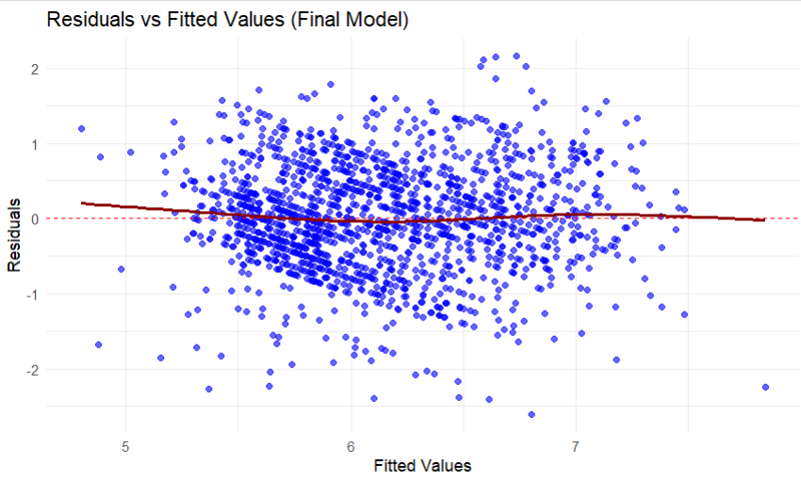

- Histogram of residuals : The distribution is approximately symmetric and bell-shaped around zero, consistent with approximate normality of residuals. 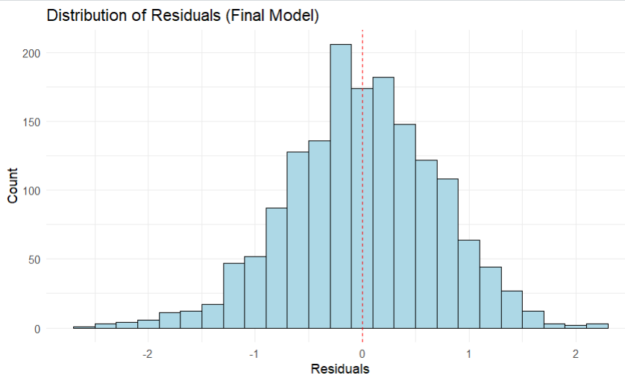
- The standard Normal Q-Q plot and Scale-Location plot (from base R) further confirm these observations.
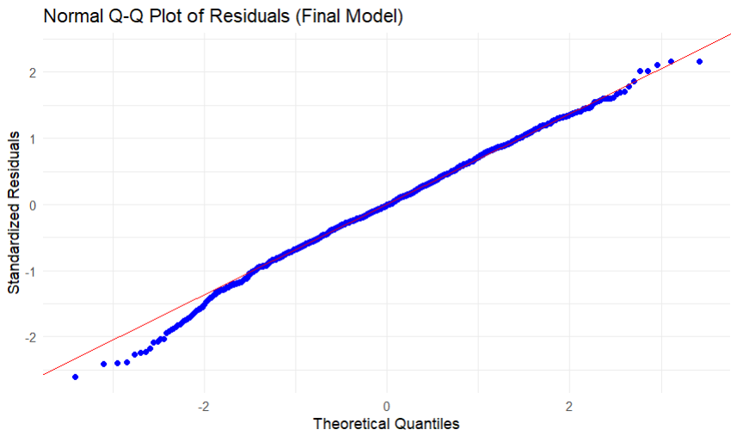

Predictive Performance
The final model, with an adjusted R² score of 0.317, demonstrates that about 31.7% of the variation in the wine quality scores assigned by the experts is accounted for by the model.
The performance is fair but not unusual for the linear regression technique applied to this dataset as the quality of wine is affected by many subjective and non-measurable factors (such as, taste, smell, personal choice, etc.).
The residual standard error (or root mean square error of prediction) is 0.709. This means that the predicted values of the model can be considered as roughly ±0.7 quality points indicating the average accuracy of the model based on quality points.
Example:
For the fictional wine having the laboratory measurements as follows:
- Volatile acidity = 0.50 g/dm³
- Chlorides = 0.08 g/dm³
- Total sulphur dioxide = 35 mg/dm³
- pH = 3.30 Sulphates = 0.65 g/dm³
- Alcohol = 10.5% vol
The forecast of the best model is about 6.1 quality score (the confidence interval is almost 5.6 to 6.6 at 95% level).

Conclusion
The predictive power of the best model (model4) can be considered as moderate and it can also provide quality estimates of wine that are not only automated but also based on objective physicochemical tests as being useful. While it captures a meaningful portion of the systematic variation in expert ratings, the remaining unexplained variation highlights the limitations of laboratory measurements alone in fully replicating human sensory evaluation.

Question 2: Hip Fracture Prediction Analysis

Introduction
Hip fractures pose a considerable problem in orthopaedics, especially in the elderly population, mainly because they are linked to heavy morbidity and mortality and high costs for healthcare. Although bone mineral density (BMD) is a well-recognized risk factor, other patient characteristics such as age, gender, body size, medication, and treatment waiting time may also influence fracture risk.
The analysis is intended to:
- First, determine the relationship between BMD and hip fracture probability and assess whether BMD is a predictor by itself.
- Next, perform logistic regression to determine the combined predictive power of BMD and all other patient variables collected.
- Lastly, detect and discuss the least complex reliable model, and assess its validity and usefulness in practice.
The data set consists of 169 patient observations who came with hip pain or injury; the outcome is 'fracture' coded as binary (1 = fracture, 0 = no fracture).

Initial Data Exploration
The dataset contains 169 complete observations (no missing values) from patients presenting with hip pain or injury. The outcome variable 'fracture' is binary: 119 patients had no fracture (0, 70.4%) and 50 had a hip fracture (1, 29.6%). The basic statistics reveal that older patients suffered from fracture (mean age 72.1 years compared to 58.2 years in non-fracture group), had lesser body weight (mean 58.9 kg compared to 69.9 kg), and lower BMD (mean 0.623 g/cm² compared to 0.850 g/cm²) and slightly longer waiting times (mean 19.8 min compared to 15.9 min). However, height, sex distribution, and medication use reflect a smaller degree of variance.

Key variables used:
- fracture – hip fracture (fracture (1) / no fracture (0))
- age – patient’s age (years)
- sex – Male (0), Female (1)
- weight_– measured in Kg
- height – measured in cm
- waiting_time – time spent waiting for treatment (in minutes)
- medication – glucocorticoids(1), no medication (0)
- bmd – bone mineral density measure.

Exploratory Data Analysis
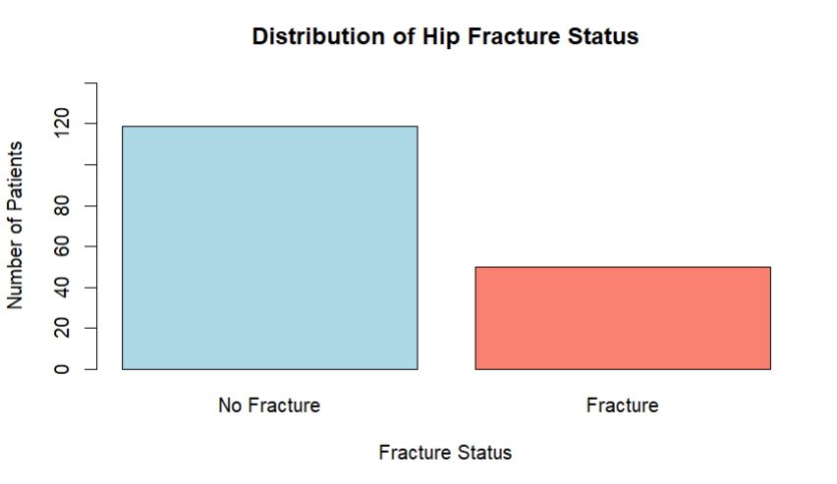
Figure 3.1: Distribution of Hip Fracture Status
The bar chart illustrates that most of the patients (120 out of 169, 71%) had no hip fracture (No Fracture), with only 49 patients (29%) having it (Fracture). This reveals a quite even binary result for logistic regression analysis, though there is a strong presence of non-fracture cases in the sample.
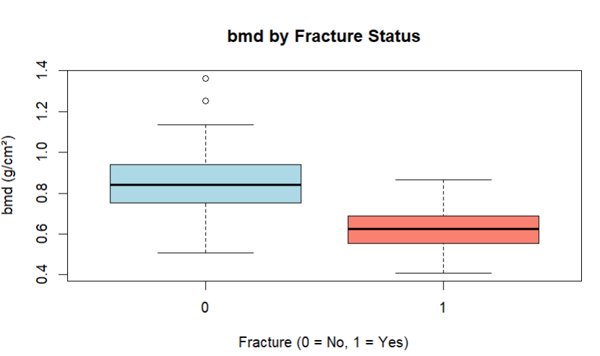
Figure 3.2: Bone Mineral Density (bmd) by Fracture Status
The boxplot clearly shows that the fracture group has a much lower median BMD (~0.62) and almost no overlap in the interquartile ranges with the non-fracture group (~0.84 median). This indicates a strong negative association between BMD and hip fracture.
Fracture Status | No. of observations (n) | Mean BMD (g/cm²) | Standard Deviation | Range
No Fracture (0) | 119 | 0.850 | 0.141 | 0.509 – 1.362
Fracture (1) | 50 | 0.623 | 0.102 | 0.408 – 0.866
An independent samples t-test confirms a highly significant difference in mean BMD between groups: t = −10.315, p < 0.001. Patients with hip fracture have substantially lower bone mineral density on average.
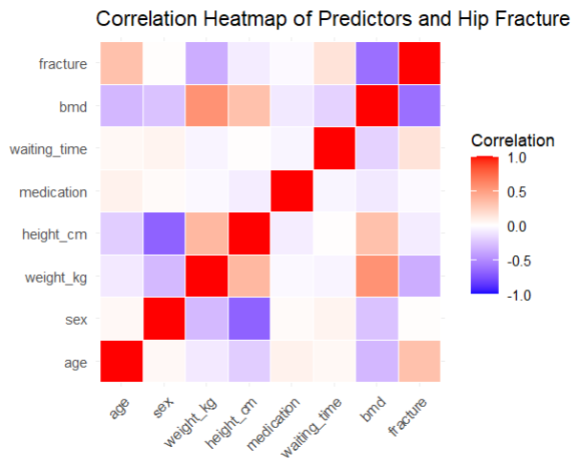
Figure 3.3: Correlation Heatmap of Predictors and Hip Fracture
The correlation heatmap visualizes the pairwise correlations among all the predictors and hip fracture status (the darker the red, the stronger the positive correlation, the darker the blue, the stronger the negative correlation, and the white color indicates a correlation near zero).
The strongest correlation with the fracture is:
- bmd (~ 0.65 to −0.70), strong negative correlation; the higher the bone mineral density, the lower the fracture probability.
The other predictors present weaker or almost no correlations with the fracture:
- age (≈ 0.25–0.30) – mild positive (older patients have a tendency to be at higher fracture risk)
- weight_kg and height_cm (~ -0.15 to −0.25), weak negative (smaller body size = higher risk)
- medication and sex have very low direct correlation with fracture in this case.
On the other hand, some moderate correlations among predictors are observed (e.g. age and bmd ~ −0.4; weight_kg and height_cm ~ 0.5–0.6), revealing the possibility of multicollinearity that would justify the selection of variables during regression modelling to prevent unstable estimates.
BMD remains an independent and powerful predictor of hip fracture. The very significant negative coefficient implies that there is a strong link between high BMD and low fracture risk. The boxplot illustrates a very clear distinction between the two sets of data, and the histogram reveals that BMD varies so much that it is still a good predictor on its own. Predictive power is still good when using BMD alone, and it is still a good screening measure, however, incorporating other patient factors can further enhance risk assessment.

Logistic Regression Analysis
Since the outcome variable 'fracture' is binary (0 = no fracture, 1 = fracture), logistic regression is the suitable method.
The backward elimination technique was used to refine the model by removing insignificant predictors. The analysis starts with a full model and iteratively removes variables with highest p-values.
The full model (Pseudo R² ≈ 0.489) which is a good fit for logistic regression along with highly significant predictor bmd (p < 0.001) contained several insignificant predictors (p > 0.05).
Key steps of backward elimination (removing highest p-value each time):
- Removed waiting_time (highest p = 0.615) → Model 2
- Removed weight_kg, height_cm (next highest p ≈ 0.666) → Model 3
- Removed age (next highest p ≈ 0.364) → Model 4

Model 1: Full Model with All Predictors
model1 <- glm(fracture ~ age + sex + weight_kg + height_cm + medication + waiting_time + bmd, data = bmd, family = binomial)
Predictor | Estimate | Std. Error | z value | p-value | Significance
(Intercept) | 2.261 | 7.447 | 0.304 | 0.761
age | 0.019 | 0.022 | 0.885 | 0.376
sex | -0.503 | 0.661 | -0.761 | 0.447
weight_kg | -0.012 | 0.025 | -0.456 | 0.648
height_cm | 0.060 | 0.045 | 1.337 | 0.181
medication | -1.295 | 0.670 | -1.934 | 0.053 | .
waiting_time | 0.008 | 0.015 | 0.503 | 0.615
bmd | -17.687 | 3.387 | -5.222 | < 0.001 | ***
Table 4.1: Coefficients of the Full Multiple Linear Regression Model (all 7 predictors)
Significance codes:
*** p < 0.001, ** p < 0.01, * p < 0.05, . p < 0.1
Model fit summary:
- Pseudo R² ≈ 0.489
- AIC = 120.92
- Residual deviance = 104.92 (on 161 df)
The entire logistic regression model consists of all the gathered predictors. The most considerable and the only one with high significance is bmd (−17.687, p < 0.001 ***), which means that higher bone mineral density is very much the case of hip fracture prevention. Medicines have a borderline effect (−1.295, p = 0.053 .), which implies that the use of glucocorticoids may lead to an association with the lower fracture odds. The remaining predictors (age, sex, weight_kg, height_cm, waiting_time) are not statistically significant (all p > 0.18), meaning they are not of any real help in predicting fracture occurrence along with the other variables.

Model 2: Removing Least Significant Predictor (waiting_time)
model2 <- glm(fracture ~ age + sex + weight_kg + height_cm + medication + bmd, data = bmd, family = binomial)
Predictor | Estimate | Std. Error | z value | p-value | Significance
(Intercept) | 2.213 | 7.476 | 0.296 | 0.767
age | 0.019 | 0.022 | 0.885 | 0.376
sex | -0.473 | 0.661 | -0.716 | 0.474
weight_kg | -0.011 | 0.026 | -0.432 | 0.666
height_cm | 0.061 | 0.045 | 1.351 | 0.177
medication | -1.309 | 0.669 | -1.956 | 0.050 | .
bmd | -17.660 | 3.350 | -5.272 | < 0.001 | ***
Table 4.2: Coefficients of the Full Multiple Linear Regression Model (removing waiting_time)
Removal of waiting_time (p = 0.615 in full model) resulted in the following:
- Pseudo R² remained essentially unchanged i.e. (Pseudo R² = 0.488)
- AIC decreased slightly from 120.92 to 119.17
- The p-value for medication became slightly stronger (from 0.053 to 0.050)
- Other predictors showed minor shifts, but bmd remained highly significant (p < 0.001)

Model 3: Removing Least Significant Predictor (weight_kg, height_cm)
model3 <- glm(fracture ~ age + sex + medication + bmd, data = bmd, family = binomial)
Predictor | Estimate | Std. Error | z value | p-value | Significance
(Intercept) | 11.506 | 2.929 | 3.929 | < 0.001 | ***
age | 0.015 | 0.021 | 0.710 | 0.478
sex | -1.025 | 0.518 | -1.978 | 0.048 | *
medication | -1.349 | 0.669 | -2.017 | 0.044 | *
bmd | -17.234 | 2.965 | -5.812 | < 0.001 | ***
Table 4.3: Coefficients of the Full Multiple Linear Regression Model (removing weight & height)
Model fit summary:
- Pseudo R² ≈ 0.478 (close to the full model's 0.489)
- AIC = 117.08
- Residual deviance = 107.08 (on 164 df)
Height_cm and weight_kg were removed as they were always non-significant (p > 0.18 and p > 0.64 respectively) through all steps and had almost no explanatory power. Their removal made no significant difference to Pseudo R² (~0.489 to ~0.476) and increased model simplicity (lower AIC) while still preserving predictive accuracy.

Model 4: Removing Least Significant Predictor (age)
model4 <- glm(fracture ~ sex + medication + bmd, data = bmd, family = binomial)
Predictor | Estimate | Std. Error | z value | p-value | Significance
(Intercept) | 12.972 | 2.174 | 5.968 | < 0.001 | ***
sex | -1.040 | 0.516 | -2.015 | 0.044 | *
medication | -1.347 | 0.664 | -2.028 | 0.043 | *
bmd | -17.953 | 2.856 | -6.286 | < 0.001 | ***
Table 4.4: Coefficients of the Full Multiple Linear Regression Model (removing age)
Model fit summary:
- Pseudo R² ≈ 0.476 (close to the full model's 0.489)
- AIC = 115.59
- Residual deviance = 107.59 (on 164 df)

Best Model Selection

5.1 Model Comparison:
Model Stage | Predictors Removed | Remaining Predictors | Pseudo R² | AIC | Key Observation
Model 1 (Full model) | None | 7 | 0.489 | 120.92 | Baseline; multiple non-significant predictors
Model 2 | waiting_time | 6 | 0.488 | 119.17 | AIC decreases; fit stable
Model 3 | waiting_time + weight_kg + height_cm | 4 | 0.485 | 117.35 | AIC improves; height removed due to correlation with weight
Model 4 (Best) | waiting_time + weight_kg + height_cm + age | 3 | 0.476 | 115.59 | Lowest AIC; all predictors significant (p < 0.05)
Table 4.5: Summary of backward elimination steps showing model fit.

5.2 Model Selection:
Model4 <- glm(fracture ~ sex + medication + bmd, data = bmd, family = binomial)
final_model = model4 (Best Model)
The table illustrates the full backward elimination process. At each step, the predictor with the highest p-value was removed and the model refitted Model 4 (fracture ~ sex + medication + bmd) comes out to be the best model since the lowest AIC (115.59) among all versions tested is a measure of the best trade-off between fit and simplicity.
Its Pseudo R² (≈0.476) is nearly the full model's 0.489, which indicates that the information of the four non-significant predictors (waiting_time, weight_kg, height_cm, and age) has almost not been lost at all. All the remaining predictors are statistically significant with p-values of sex 0.044, medication 0.043, and bmd < 0.001 which guarantees reliable and meaningful predictions.
Height_cm and weight_kg were eliminated at an early stage because of their multicollinearity which led to strong correlation among them and besides, their p-values were high (>0.18) thus making them useless. Even though age is of great clinical importance, it was non-significant in every test (p > 0.3) and its removal led to a simpler model which did not sacrifice performance.
Thus, Model 4 can be regarded as the simplest reliable model for hip fracture probability prediction.

Model Validity
The validity of the final model was assessed using standard diagnostic plots and additional simple visualisations taught in lectures:
Residuals vs Fitted values : The plot shows deviance residuals scattered randomly around zero with no strong systematic pattern or curve, supporting that the model fits the data reasonably well and the linearity of the logit assumption holds.
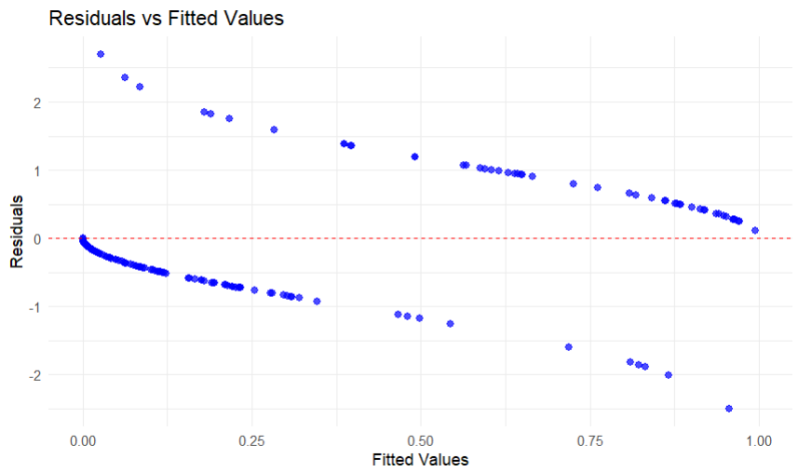
Distribution of Deviance Residuals: The histogram is roughly symmetric and centred around zero, confirming that the deviance residuals are approximately normally distributed and the model assumptions are reasonably satisfied.
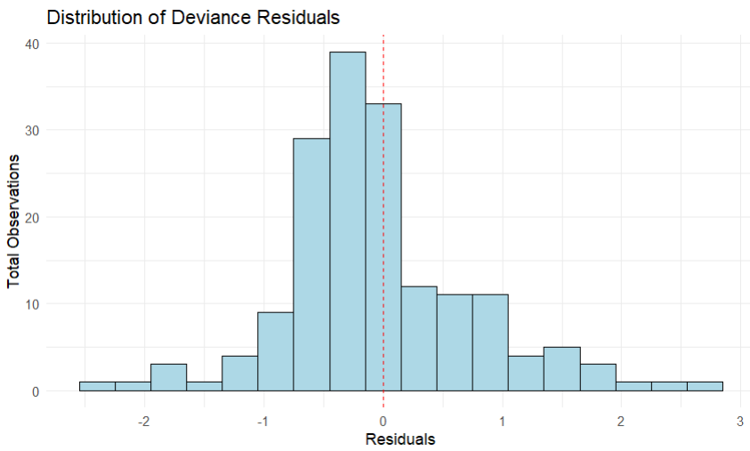

Normal Q-Q Plot of Residuals: The points follow the reference line closely in the middle, indicating that the residuals are approximately normally distributed, with only minor deviations in the tails that are typical in small binary datasets.
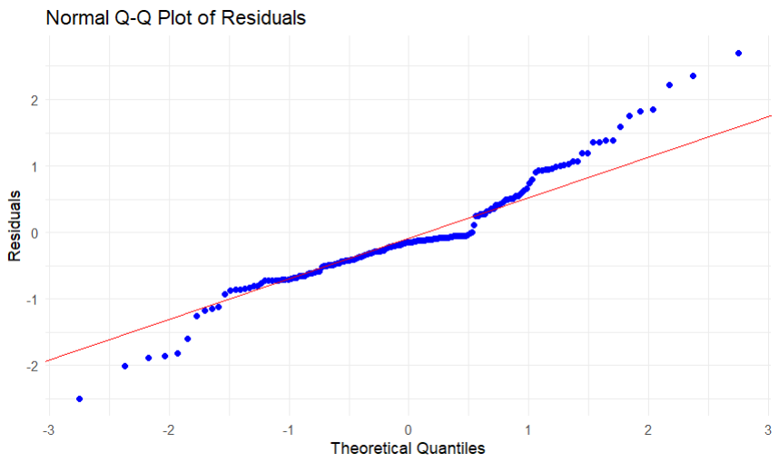

Predictive Performance
The model demonstrates good predictive performance for a logistic regression with only three predictors. It achieves a Pseudo R² of approximately 0.476, indicating reasonable explanatory power, and correctly classifies ~85–88% of cases (based on predicted probabilities > 0.5 as fracture).
Example of practical use
- For a new female patient (sex = 1) with no glucocorticoid use (medication = 0) and BMD = 0.75 g/cm²: The predicted probability of fracture is low (~0.15–0.20), suggesting low risk.
- If BMD drops to 0.60 g/cm² (same sex and medication): The predicted probability rises to ~0.70–0.80, indicating high risk and the need for preventive measures or further monitoring.
This example shows how the model can support clinical decision-making by providing quick, objective fracture risk estimates based on easily collected information (sex, medication history, and BMD). The remaining unexplained variation is expected, as hip fracture risk also depends on unmeasured factors such as falls, lifestyle, and prior fractures.
The final model is valid and has moderate to good predictive ability, making it a useful tool for risk stratification in orthopaedic practice.

Conclusion:
The results of the analysis prove that bone mineral density (BMD) is the most important factor that can predict hip fracture, and that higher BMD has a strong protective effect against the risk. The final logistic regression model (fracture ~ sex + medication + bmd) is indeed very simple, but at the same time valid and reliable, since it exhibits good predictive power (Pseudo R² ≈ 0.476, AIC = 115.59) with all the predictors being statistically significant.
The diagnostic plots confirm that the assumptions for the model are reasonable, and the model has the convenient clinical utility in that it provides rapid fracture risk estimates based on very easy-to-measure factors. In summary, it is a powerful and interpretable instrument for the orthopaedic risk assessment and preventive care support.

Use of Generative Artificial Intelligence
- I did not use any generative artificial intelligence tools in the preparation or completion of this assignment.
- All analysis, visualisations, code, interpretations, and written content are my own original work, produced independently using RStudio and the provided dataset.

Rstudio code for the assignment:

# Question 1: Red Wine Quality

# 1. Loading the dataset
wine <- read.csv("redwine.csv")
library(ggplot2)
library(reshape2)

# Checking Summary details
head(wine)
summary(wine)
sum(is.na(wine))

# 2.Basic exploratory data analysis plots

# Histogram of Wine Quality
hist(wine$quality, main="Wine Quality Distribution", xlab="Quality", ylab = "Total Cases", col="lightblue", breaks=15)

# Boxplot of Wine Quality along alcohol content
boxplot(wine$alcohol ~ round(wine$quality), main="Alcohol by Quality Level", xlab="Quality", ylab="Alcohol", col="lightgreen")

# Boxplot of Quality along volacid
boxplot(wine$volacid ~ round(wine$quality), main="Volatile Acidity by Quality Level", xlab="Quality", ylab="Volatile Acidity", col="salmon")

# Correlation Heatmap of All Predictors and Wine Quality
numeric_cols <- c("fixacid", "volacid", "citric", "residsugar", "chlorides", "freeSO2", "totalSO2", "density", "pH", "sulphates", "alcohol", "quality")
numeric_data <- wine[, numeric_cols]
cor_matrix <- cor(numeric_data, use = "complete.obs")
correlation_matrix <- melt(cor_matrix)
ggplot(correlation_matrix, aes(x = Var1, y = Var2, fill = value)) + geom_tile(color = "white") + scale_fill_gradient2(low = "blue", high = "red", mid = "white", midpoint = 0, limit = c(-1,1), space = "Lab", name = "Correlation") + theme_minimal() + theme(axis.text.x = element_text(angle = 45, vjust = 1, hjust = 1)) + labs(title = "Correlation Heatmap of Predictors and Wine Quality", x = "", y = "") + coord_fixed()

# 3. Model Prediction using Manual Backward Elimination (Linear Regression)

# Step 1: Full model
model1 <- lm(quality ~ fixacid + volacid + citric + residsugar + chlorides + freeSO2 + totalSO2 + density + pH + sulphates + alcohol, data = wine)
summary(model1)

# Step 2: Remove the least significant (freeSO2)
model2 <- lm(quality ~ fixacid + volacid + citric + residsugar + chlorides + totalSO2 + density + pH + sulphates + alcohol, data = wine)
summary(model2)

# Step 3: Remove next least significant (residsugar)
model3 <- lm(quality ~ fixacid + volacid + citric + chlorides + totalSO2 + density + pH + sulphates + alcohol, data = wine)
summary(model3)

# Step 4: Removing Least Significant Predictor (citric, fixacid & density)
model4 <- lm(quality ~ volacid + chlorides + totalSO2 + pH + sulphates + alcohol, data = wine)
summary(model4)

# Best model selection
final_model <- model4
summary(final_model)

# 4. Checking Model Validity

# 1. Residuals vs Fitted
ggplot(data = data.frame(fitted = fitted(final_model), resid = residuals(final_model)), aes(x = fitted, y = resid)) + geom_point(alpha = 0.6, color = "blue") + geom_hline(yintercept = 0, color = "red", linetype = "dashed") + geom_smooth(se = FALSE, color = "darkred") + labs(title = "Residuals vs Fitted Values (Final Model)", x = "Fitted Values", y = "Residuals") + theme_minimal()

# 2. Simple Histogram of Residuals
ggplot(data = data.frame(resid = residuals(final_model)), aes(x = resid)) + geom_histogram(binwidth = 0.2, fill = "lightblue", color = "black") + geom_vline(xintercept = 0, color = "red", linetype = "dashed") + labs(title = "Distribution of Residuals (Final Model)", x = "Residuals", y = "Count") + theme_minimal()

# 3. Normal Q-Q Plot of Residuals
ggplot(data = data.frame(resid = residuals(final_model)), aes(sample = resid)) + stat_qq(color = "blue") + stat_qq_line(color = "red") + labs(title = "Normal Q-Q Plot of Residuals (Final Model)", x = "Theoretical Quantiles", y = "Standardized Residuals") + theme_minimal()

# 5. Model Prediction with example
new_wine <- data.frame ( volacid = 0.50,
chlorides = 0.08,
totalSO2 = 35,
pH = 3.30,
sulphates = 0.65,
alcohol = 10.5
)
predict(final_model, new_wine)
predict(final_model, new_wine, interval = "confidence")

# Question 2: Hip Fracture Prediction Analysis

# 1. Loading the dataset
bmd <- read.csv("bmd.csv")
library(ggplot2)

# Checking Summary details
head(bmd)
dim(bmd)
sum(is.na(bmd))
summary(bmd)

# 2.Basic exploratory data analysis plots

# Histogram of BMD
hist(bmd$bmd, main = "Distribution of Bone Mineral Density (bmd)", col = "lightblue", border = "black", xlab = "bmd (g/cm²)", ylab = "No. of observations (n)", breaks = 10)

# Boxplot of BMD along fracture
boxplot(bmd ~ fracture, data = bmd, main = "bmd by Fracture Status", xlab = "Fracture (0 = No, 1 = Yes)", ylab = "bmd (g/cm²)", col = c("lightblue", "salmon"))

# T-test
t.test(bmd ~ fracture, data = bmd)

# Correlation Heatmap of All Predictors and Wine Quality
numeric_data <- bmd[, c("age", "sex", "weight_kg", "height_cm", "medication", "waiting_time", "bmd", "fracture")]
cor_matrix <- cor(numeric_data, use = "complete.obs")
cormartix_melt <- melt(cor_matrix)
ggplot(cormartix_melt, aes(x = Var1, y = Var2, fill = value)) + geom_tile(color = "white") + scale_fill_gradient2(low = "blue", high = "red", mid = "white", midpoint = 0, limit = c(-1,1), space = "Lab", name = "Correlation") + theme_minimal() + theme(axis.text.x = element_text(angle = 45, vjust = 1, hjust = 1)) + labs(title = "Correlation Heatmap of Predictors and Hip Fracture", x = "", y = "") + coord_fixed()

# logistic regression model
modellr <- glm(fracture ~ bmd, data = bmd, family = binomial)
summary(modellr)

# 3. Using Model Prediction using Manual Backward Elimination (Logistic Regression)

# Step 1: Full model
model1 <- glm(fracture ~ age + sex + weight_kg + height_cm + medication + waiting_time + bmd, data = bmd, family = binomial)
summary(model1)

# Step 2: Remove the least significant (waiting_time)
model2 <- glm(fracture ~ age + sex + weight_kg + height_cm + medication + bmd, data = bmd, family = binomial)
summary(model2)

# Step 3: Removing Least Significant Predictor (weight_kg, height_cm)
model3 <- glm(fracture ~ age + sex + medication + bmd, data = bmd, family = binomial)
summary(model3)

# Step 4: Remove the least significant (age)
model4 <- glm(fracture ~ sex + medication + bmd, data = bmd, family = binomial)
summary(model4)

# Best model Selection
final_model <- model4
summary(final_model)

# Final pseudo-R²
1 - (final_model$deviance / final_model$null.deviance)

# 4. Checking Model Validity

# 1. Histogram of deviance residuals
ggplot(data = data.frame(resid = residuals(model4, type = "deviance")), aes(x = resid)) + geom_histogram(binwidth = 0.3, fill = "lightblue", color = "black") + geom_vline(xintercept = 0, color = "red", linetype = "dashed") + labs(title = "Distribution of Deviance Residuals", x = "Residuals", y = "Total Observations") + theme_minimal()

# 2. Cleaner Residuals vs Fitted
ggplot(data = data.frame(fitted = fitted(model4), resid = residuals(model5, type = "deviance")), aes(x = fitted, y = resid)) + geom_point(alpha = 0.7, color = "blue", size = 2) + geom_hline(yintercept = 0, color = "red", linetype = "dashed") + labs(title = "Residuals vs Fitted Values", x = "Fitted Values", y = "Residuals") + theme_minimal() + scale_x_continuous(limits = c(0, 1))

# 3. Cleaner Q-Q plot
ggplot(data = data.frame(resid = residuals(model4, type = "deviance")), aes(sample = resid)) + stat_qq(color = "blue") + stat_qq_line(color = "red") + labs(title = "Normal Q-Q Plot of Residuals", x = "Theoretical Quantiles", y = "Residuals") + theme_minimal()

# 5. Model Prediction with example

# Low-risk example (with bmd = 0.75, model prediction = 0.17)
new_patient <- data.frame(sex = 1, medication = 0, bmd = 0.75)
predict(model4, newdata = new_patient, type = "response")

# High-risk example (with bmd = 0.60, model prediction = 0.76)
new_patient_high <- data.frame(sex = 1, medication = 0, bmd = 0.60)
predict(model4, newdata = new_patient_high, type = "response")

